AI-AUGMENTED BACKEND DEVELOPMENT
AI BLOGNEST API
ROLE | TEAM MEMBER
TEAM LEADER | J. JANANI
TEAM MEMBER | G. KIRTHIKA
TEAM MEMBER | R. NANDHINI
TEAM MEMBER | V. NISHA
PHASE 7 – PROJECT DOCUMENTATION

1. Introduction
The Database Configuration phase connects AI BlogNest API with MongoDB and defines the data structures required by the application. 2. MongoDB Configuration
- Set up the MongoDB database.
- Install Mongoose in the Node.js project.
- Configure the database connection using environment variables.
- Verify that the backend connects successfully before performing database operations.
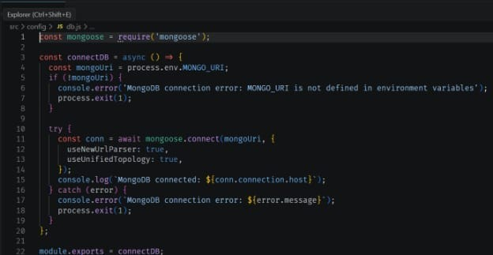

3. Main Data Models
- User model – stores name, email, password and role.
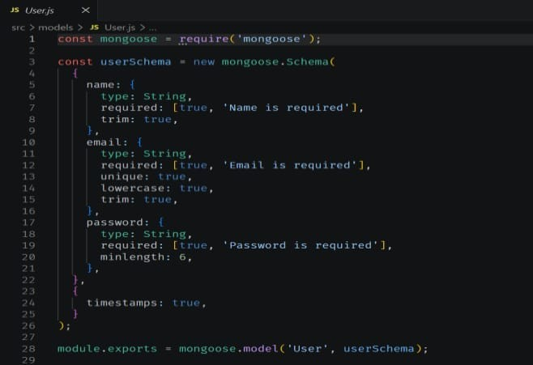
- Post model – stores author reference, title, content, image information and timestamps.
- Comment model – stores user, post and comment information.
- Category/Tag information – supports content organization and filtering.

4. Mongoose Schemas
- Define required fields and data types.
- Apply unique constraints where required.
- Use validation rules for important fields.
- Create references between related documents.
- Use timestamps where appropriate.

5. Database Operations
- Create and save documents.
- Retrieve documents using queries.
- Update existing records.
- Delete records when authorized.
- Use relationships and references to connect application data.
6. Expected Outcome
The backend is connected to MongoDB with structured schemas and reliable data operations.

7. Conclusion
Database Configuration provides persistent storage for users, blog posts, comments and other information required by AI BlogNest API.

